
Dashboard Design

Team ID | MCA
Project Name
Maximum Marks | 5 Marks

Creating an effective dashboard involves thoughtful design to ensure that the presented information is clear, relevant, and easily understandable for the intended audience. Here are some key principles and best practices for dashboard design
Activity 1: Interactive and visually appealing dashboards
Creating an effective dashboard involves thoughtful design to ensure that the presented information is clear, relevant, and easily understandable for the intended audience. Below are the key outcomes and best practices applied to the smartphone usage dashboard layout
- Total Screen Time Tracked
- App Category Revenue/Engagement
- Use Appropriate Visualizations
- Colour and Theming
- Interactive Filters and Slicers
- Drill-Down Capabilities
- Responsive Design
- Custom Visuals and Icons
- Use of Infographics

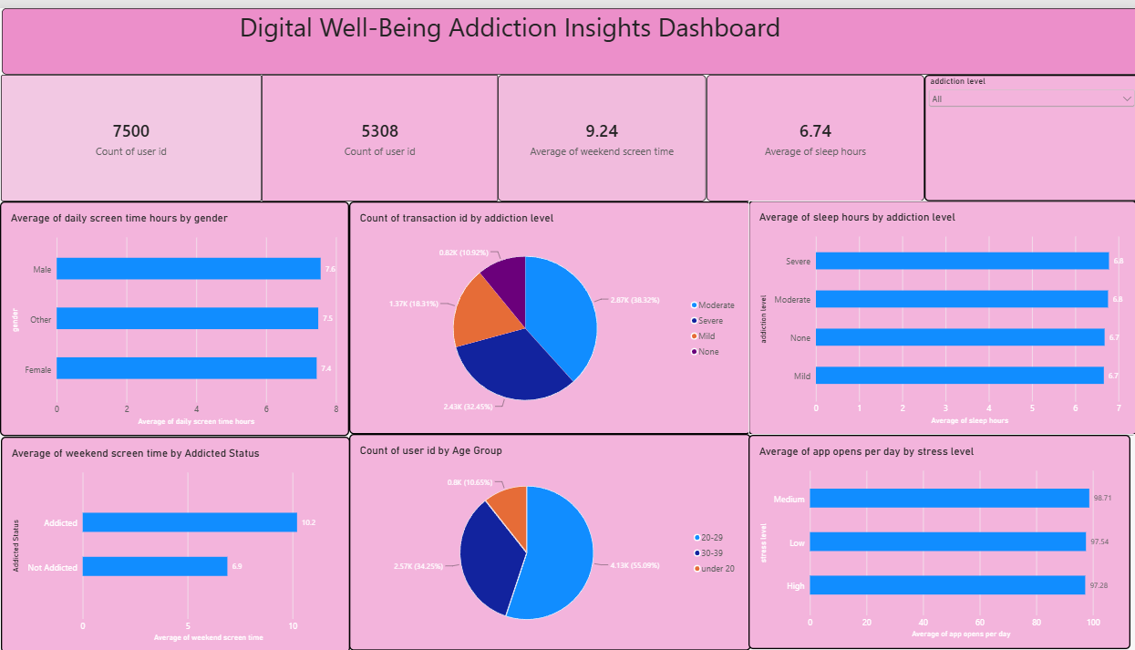

Note: Highlight the major outcomes in form of bullet points
Sample:
Here are five potential outcomes from the dashboard image provided:
- Total Screen Time Tracked: The dashboard tracks cumulative usage metrics across different demographics to pinpoint high-engagement intervals.
- App Category Revenue/Engagement: Displays financial generation or user engagement broken down by app category (e.g., Social Media, Productivity, Gaming).
- Active User Base: Monitors the total number of unique active device logs to understand platform retention.
- Yearly Usage Trends: A dedicated bar chart visualizes consumption growth year-over-year, helping identify shifting digital habits.
- Daily Distribution Analysis: A pie chart splits usage frequencies by the day of the week to reveal peak usage days (e.g., weekends vs. weekdays).

